**NETWORKING (LTSA)**

**A PROJECT REPORT SUBMITTED**

**by**

**AJAY KUMAR PANCHAL**

**University Roll No – 1900290149006**

**Submitted in partial fulfillment of the**

**Requirements for the Degree of**

**Master of Computer Application**

**Under the Supervision of**

**Dr. Sangeeta Arora**

### ASSOCIATE PROFESSOR



**Submitted to**

**Faculty of MCA**

**DR. APJ ABDUL KALAM TECHNICAL UNIVERSITY LUCKNOW**

**(Formerly Uttar Pradesh Technical University, Lucknow)**

**(August 2021)**

DECLARATION

I hereby declare that the work presented in this report entitled “NETWORKING(LTSA)”, was carried out by me. I have not submitted the matter embodied in this report for the award of any other degree or diploma of any other University or Institute.

I have given due credit to the original authors/sources for all the words, ideas, diagrams, graphics, computer programs, experiments, results, that are not my original contribution. I have used quotation marks to identify verbatim sentences and given credit to the original authors/sources.

I affirm that no portion of my work is plagiarized, and the experiments and results reported in the report are not manipulated. In the event of a complaint of plagiarism and the manipulation of the experiments and results, I shall be fully responsible and answerable.

Name : Ajay Kumar Panchal

Roll. No. : 1900290149006

Branch : Master of Computer Application

**(Candidate Signature)**

CERTIFICATE

Certified that **Ajay Kumar Panchal** (**1900290149006**) has carried out the project work presented in this report entitled “**NETWORKING(LTSA)**” for the award of **Master of Computer Application** from Dr. A.P.J. Abdul Kalam Technical University, Lucknow under my supervision. The report embodies result of original work, and studies are carried out by the student himself and the contents of the report do not form the basis for the award of any other degree to the candidate or to anybody else from this or any other University.

**Dr. Sangeeta Arora External Examiner**

Associate Professor

Dept. of Computer Applications

KIET Group of Institutions, Ghaziabad

**Dr. Ajay Kumar Srivastava**

Professor & Head

Department of Computer Applications

KIET Group of Institutions, Ghaziabad

Date: 02/08/2021

NETWORKING (LTSA)

Ajay Kumar Panchal

ABSTRACT

This project is a Web Application based resolve the user problem related to networking. The project objective is to find the solution of networking and provide the best network into web platform.

This project is an attempt to provide the advantages of network to customers of a best networking. It helps to use the best services of networking in the place anywhere through networking by using a web device. Thus, the customer will get the service of online and service for his/her good connection. This system can be implemented to any connection in her/his locality through networking.

If networking is providing in the world, then the customers can enjoy easy service from anywhere, the services will not be losing any more customers to the trending of uses internet. Since the application is available through the internet it is easily accessible and always available.

ACKNOWLEDGEMENT

I take this occasion to thank God, almighty for blessing us with his grace and taking our endeavor to a successful culmination. I extend my sincere and heartfelt thanks to our esteemed guide, **Dr**. **Sangeeta Arora**, for providing me with the right guidance and advice at the crucial junctures and for showing me the right way. I extend my sincere thanks to our respected **Head of the department Dr. Ajay Kumar Shrivastava**, for allowing us to use the facilities available. I would like to thank the other faculty members also, at this occasion. Last but not the least, I would like to thank my friends and family for the support and encouragement they have given me during our work.

**AJAY KUMAR PANCHAL**

**Roll No. 1900290149006**

TABLE OF CONTENTS

|  |  |
| --- | --- |
| DECLARATION | ii |
| CERTIFICATE | iii-iv |
| ABSTRACT | v |
| ACKNOWLEDGEMENT | vi |
| LIST OF FIGURES | x-xi |
| LIST OF TABLES | xii |
|  |  |
| 1. CHAPTER: Introduction | 1-19 |
| 1.1 Project Detail | 2-6 |
| 1.1.1 Definition | 3-6 |
| 1.2 Project Scope | 7-9 |
| 1.2.1 Local Area Network | 8 |
| 1.2.2 Wide Area Network | 9 |
| 1.3 Hardware used in Project | 10-16 |
| 1.4 Software used in Project | 17-19 |
|  |  |
| 2. CHAPTER: Literature Review | 20-24 |
| * 1. What is Networking | 20 |
| 2.2 How does a computer network work? | 20-22 |
| 2.3 How is computer networking evolving | 22-24 |
|  |  |
| 3. CHAPTER: Technical Feasibility | 25-27 |
| 3.1 Technical feasibility | 26 |
| 3.2 Technology Description | 26-27 |
|  |  |
| 4. CHAPTER: Backend Design | 28-36 |
| 4.1 Data Dictionary | 28-32 |
| 4.2 ER Diagram | 33 |
| 4.3 DFD | 34 |
| 4.4 Database tables | 35 |
| 4.5 Architecture | 36 |
|  |  |
| 5. CHAPTER: Frontend Design | 37-40 |
| 5.1 Input (Screenshot) | 37-39 |
| 5.2 Output Form (Screenshot) | 40 |
|  |  |
| 6. CHAPTER: Report | 41-43 |
| 6.1 Report (Screenshot) | 41-43 |
|  |  |
| 7. CHAPTER: Testing | 44-46 |
| 7.1 Test Case (Screenshot) | 44-46 |
|  |  |
| 8. CHAPTER: Limitation | 47-50 |
| 8.1 Future Scope | 48 |
| 8.2 Future Enhancement | 49-50 |
|  |  |
| 9. CHAPTER: Conclusion | 51-52 |
| 10. CHAPTER: Bibliography | 53 |
| 11. CHAPTER: References | 54-56 |
|  |  |

LIST OF FIGURES

|  |  |
| --- | --- |
| 1.1 services | 2 |
| 1.2 Connection | 3 |
| 1.3 connectivity graph | 7 |
| 1.4 LAN | 8 |
| 1.5 WAN | 9 |
| 1.6 Router | 11 |
| 1.7 Bridge | 12 |
| 1.8 Hub | 13 |
| 1.9 Repeater | 13 |
| 1.10 Gateway | 14 |
| 1.11 Switch | 15 |
| 1.12 Sequence of Devices | 16 |
| 1.13 Network Components | 19 |
|  |  |
| 4.1 Data Center | 29 |
| 4.2 Connectivity Location | 30 |
| 4.3 ER Diagram | 33 |
| 4.4 DFD Diagram | 34 |
| 4.5 Architecture | 36 |
|  |  |
| 5.1 New Cases | 37 |
| 5.2 Incident | 38 |
| 5.3 Onboarding Process | 39 |
| 5.4 Output status | 40 |
|  |  |
| 6.1 Customer Information | 41-43 |
|  |  |
| 7.1 Testing on CMD | 46 |

LIST OF TABLES

|  |  |
| --- | --- |
| 4.1 CPE | 35 |
| 4.2 User information | 35 |

CHAPTER 1

INTRODUCTION

This project is a web-based Application system for a better connectivity with us through internet. The project objective is to better networking throughout the environment.

The Network design starts from the point of topology. This will include defining the layers and defining the functionality of each layer. The main aspect of dividing the network into layers is to incorporate the functions based on the layered structure and design the connectivity methods and high availability techniques at each layer. It also helps in distribution and control of network functionality.

The design should be in such a way that there will be no single points of failure and should be capable of achieving fast and predictable convergence times. The design should also address the ease of scalability by increasing the port density in the switches. This Low-Level Design has been made in accordance with Cisco’s existing best-practice recommendations. The foundation of the design stems from Cisco’s standard ‘Multilayer Network Design’ model.

The aim of the network is to provide highly available and scalable environment for collocation of Internet, Intranet and Extranet services, and applications. It is providing high-speed access to data, voice, and internet-based applications. The network is planned such that it will provide the necessary backbone connectivity between the different offices to ensure that the network becomes an enabler for business plans.

* 1. Project Detail

We have been busy building Africa’s digital future – which increasingly belongs in the cloud.

Businesses can no longer afford to miss out on the huge opportunities being presented by cloud-based services, which are transforming IT strategies and business models worldwide.

**Africa’s Cloud provides your business with:**

Flexibility: Liquid Intelligent Technologies offers an elastic cloud model that enables our customers to scale quickly and on-demand.

**Reliability**: Liquid Intelligent Technologies provides direct connectivity to the cloud on our highly resilient, meshed network.

**Security**: Liquid Intelligent Technologies’ secure network and dedicated connections to the cloud ensure your data is always protected.

Find out more about how Liquid Intelligent Technologies can support your journey to Africa’s Cloud.

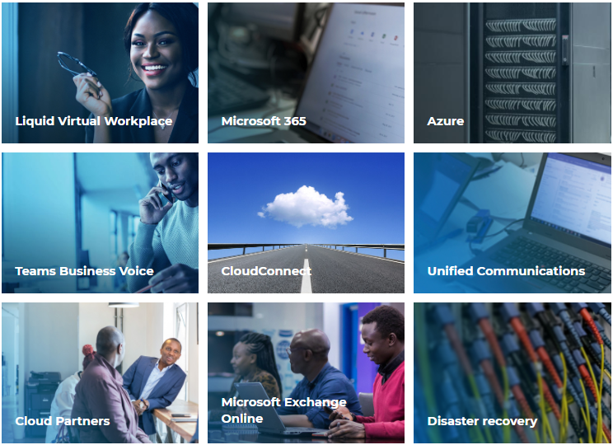

Fig. 1.1 services

1.1.1 Definition

A network is a system that transmits any combination of voice, video and/or data between users. A network can be defined by its geographical dimensions and by which the user’s PC access it. A network consists of a:

* The network operating system (Windows) on the user’s PC (client) and server.
* The cables connecting all network devices (user’s PC, server, peripherals, etc.).
* All supporting network components (hubs, routers, and switches, etc.).
* Computer Network means an interconnected collection of autonomous computers.

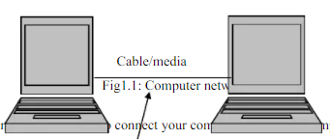

Fig. 1.2 Connection

1.1.2 Basic Connectivity Components

* Network Adapters
* Network Cables
* Wireless Communication Devices

The basic connectivity components of a network include the cables, network adapters, and wireless devices that connect the computers in the network.  
  
These components enable data to be sent to each computer on the network, thereby permitting the computers to communicate with each other.  
  
Common connectivity components of a network are:

* Network adapters.
* Network cables.
* Wireless communication devices.
* Network Adapters

Network adapters constitute the physical interface between the computer and the network cable. Network adapters, also known as network interface cards, are installed into an expansion slot in each computer and server on the network. After the network adapter is installed, the network cable is attached to the adapter's port to physically connect the computer to the network.

As the data passes through the cable to the network adapter, it is formatted into packets. A packet is a logical grouping of information that includes a header, which contains location information and user data. The header contains address fields that include information about the data's origin and destination. The network adapter reads the destination address to determine if the packet is to be delivered to this computer. If it is, the network adapter then passes the packet on to the operating system for processing. If not, the network adapter discards the packet.

Each network adapter has a unique address that is incorporated into chips on the card. This address is called the physical, or media access control (MAC), address.

The network adapter performs the following functions:

* Receives data from the computer's operating system and converts it into electrical signals that are transmitted onto the cable.
* Receives electrical signals from the cable and translates them into data that the computer's operating system can understand.
* Determines whether data received from the cable is intended for the computer.
* Controls the flow of data between the computer and the cabling system.

To ensure compatibility between the computer and the network, the network adapter must meet the following criteria:

* Fit in the computer's expansion slot.
* Use the correct type of cable connector for the cabling.
* Be supported by the computer's operating system.

* Network Cables

You connect computers together in a network by using cables to carry signals between computers. A cable that connects two computers or network components is called a segment. Cables differ in their capabilities and are categorized according to their ability to transmit data at varying speeds, with different error rates.

The three major categories of cables that connect most networks are:

* Twisted pair
* Coaxial
* Fiber-optic

* Twisted-Pair Cable

Twisted-pair cable (lO base IT) consists of two insulated strands of copper wire twisted around each other. There are two types of twisted-pair cable: unshielded twisted pair (UTP) and shielded twisted pair (STP). These are the most common cables used in networks and can carry signals for 100 meters (about 328 feet).

* UTP cable is the most popular type of twisted-pair cable and is the most popular LAN cable.
* STP cable uses a woven copper-braid Jacket that is more protective and of a higher quality than the jacket used by UTP. STP also uses a foil wraparound each of the wire pairs. This gives STP excellent shielding that protects the transmitted data from outside interference, which in turn allows STP to support higher transmission rates over longer distances than UTP.

Twisted-pair cabling uses Registered Jack 45 (RJ-45) connectors to connect to a computer. These are like Registered Jack 11 (RJ-11) connectors.

* Coaxial Cable

Coaxial cable consists of a copper wire core surrounded by insulation, a braided metal shielding, and an outer cover. The core of a coaxial cable carries the electronic signals that make up the data. This wire core can be either solid or stranded. There are two types of coaxial cable: thin Net coaxial cable (10Base2) and thick Net coaxial cable (10Base5). Coaxial cabling is a good choice when transmitting data over long distances and for reliably supporting higher data rates when using less sophisticated equipment.

Coaxial cable must be terminated at each end.

* Thinnest coaxial cable can carry a signal for approximately 185 meters (about 607 feet).
* Thick Net coaxial cable can carry a signal for 500 meters (about 1,640 feet).

Both thin Net and thick Net cable use a connection component, known as a BNC connector, to make the connections between the cable and the computers.

* Fiber-Optic Cable

Fiber-optic cable uses optical fibers to carry digital data signals in the form of modulated pulses of light. Because fiber-optic cable carries no electrical impulses, the signal cannot be tapped, and its data cannot be stolen. Fiber-optic cable is good for very high-speed, high-capacity data transmission because the signal is transmitted very quickly and with very little interference.  
A disadvantage of fiber-optic cable is that it breaks easily if you are not careful during installation. It is more difficult to cut than other cables and requires special equipment to cut it.

**1.2 Project Scope**

* There is a vast future scope of this Network. This Design can be improved and can be used by various banks. If the limitations present in this Design are removed then, this Network will become very reliable and provide 100% uptime.
* We can easily implement any changes to the Network Design as we are using the latest protocol like Border Gateway Protocol (BGP) in our network which is having attributes to easily divert or control the flow of data and QOS which can be used to allocate bandwidth to servers accordingly.

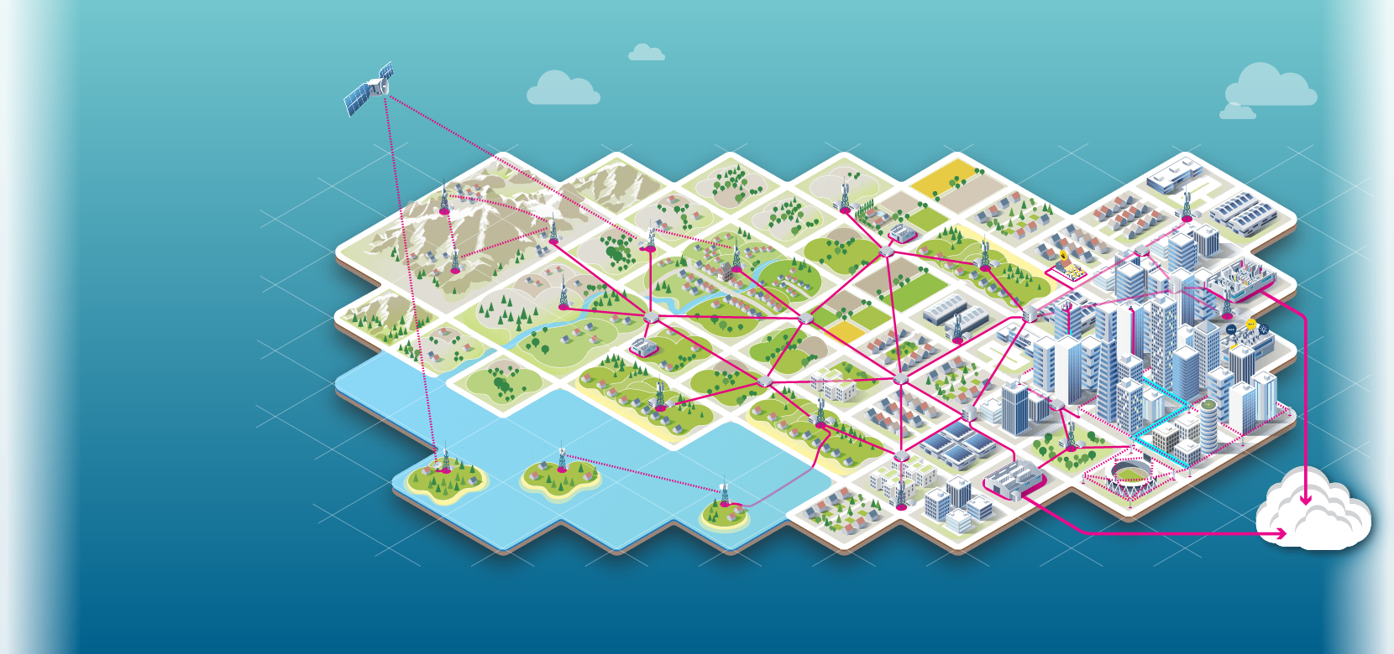

Fig. 1.3 Connectivity Graph

The scope of a network refers to its geographical size. A network can range in size from just a few computers in one office to thousands of computers linked together over great distances.  
  
Network scope is determined by the size of the organization or the distance between users on the network. The scope determines how the network is designed and what physical components are used in its construction.

There are two general types of network scope:

* Local Area Networks
* Wide Area Networks

**1.2.1** Local Area Networks

A local area network (LAN) connects computers that are located near each other.  
  
For example, two computers connected in an office or two buildings connected by a high-speed wire can be considered a LAN. A corporate network that includes several adjacent buildings can also be considered a LAN.

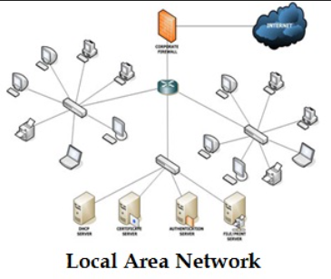

Fig. 1.4 LAN

1.2.2 Wide Area Network

A wide area network (WAN) connects several computers located at a greater distance from one another.  
  
For example, two or more computers connecting opposite sides of the world is considered a WAN. A WAN can be made up of several interconnected LANs. For example, the Internet is really a WAN.

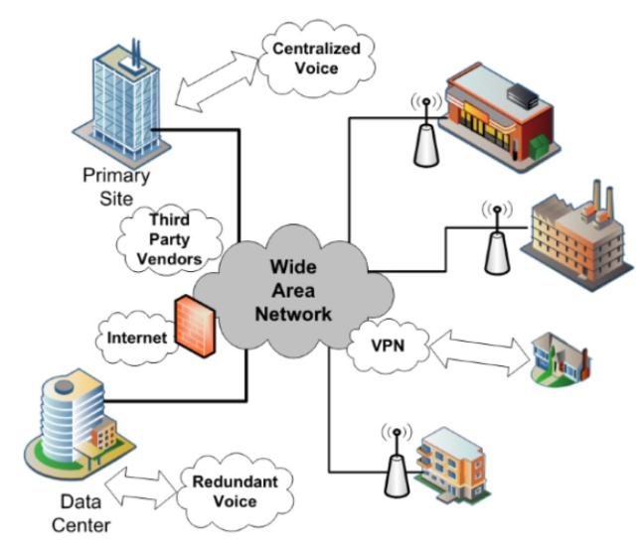

Fig. 1.5 WAN

**1.3 Hardware Tools**

The following are the tangible, hands-on tools you should have available for your use when managing and maintaining your network. While virtually monitoring your system is made easier with the right software, the network itself still lives and breathes through the technological foundation you have built here in the real world.

Servers −Servers are high-configuration computers that manage the resources of the network. The network operating system is typically installed in the server and so they give user accesses to the network resources. Servers can be of various kinds: file servers, database servers, print servers etc.

* Clients − Clients are computers that request and receive service from the servers to access and use the network resources.
* **Peers**− Peers are computers that provide as well as receive services from other peers in a workgroup network.
* **Transmission Media** − Transmission media are the channels through which data is transferred from one device to another in a network. Transmission media may be guided media like coaxial cable, fiber optic cables etc., or maybe unguided media like microwaves, infra-red waves etc.
* **Connecting Devices** − Connecting devices act as middleware between networks or computers, by binding the network media together. Some of the common connecting devices are:

**A Router:**

* A router is a hardware device which is used to connect a LAN with an internet connection. It is used to receive, analyze, and forward the incoming packets to another network.
* A router works in a Layer 3 (Network layer) of the OSI Reference model.
* A router forwards the packet based on the information available in the routing table.
* It determines the best path from the available paths for the transmission of the packet.

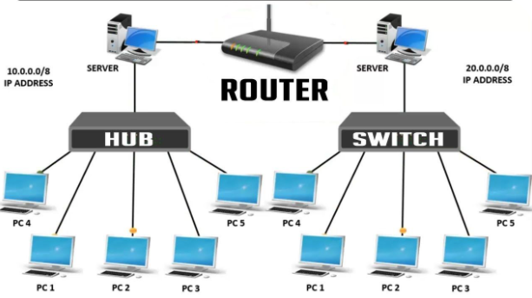

Fig. 1.6 Router

b. Bridges:

* Bridges connects two or more different LANs that has a similar protocol and provides communication between the devices (nodes) in them.
* By joining multiple LANs, bridges help in multiplying the network capacity of a single LAN.
* Since they operate at data link layer, they transmit data as data frames.

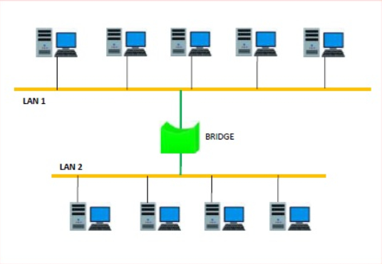

Fig. 1.7 Bridge

**c. Hubs:**

A Hub is a hardware device that divides the network connection among multiple devices. When computer requests for some information from a network, it first sends the request to the Hub through cable. Hub will broadcast this request to the entire network. All the devices will check whether the request belongs to them or not. If not, the request will be dropped.

The process used by the Hub consumes more bandwidth and limits the amount of communication. Nowadays, the use of hub is obsolete, and it is replaced by more advanced computer network components such as Switches, Routers.

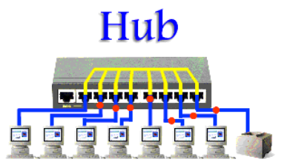

Fig. 1.8 Hub

**d. Repeaters:**

A repeater operates at the physical layer. Its job is to regenerate the signal over the same network before the signal becomes too weak or corrupted to extend the length to which the signal can be transmitted over the same network. An important point to be noted about repeaters is that they do not amplify the signal. When the signal becomes weak, they copy the signal bit by bit and regenerate it at the original strength. It is a 2-port device.

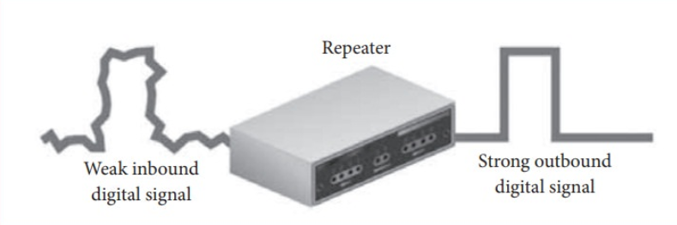

Fig. 1.9 Repeater

**e. Gateways:**

A network gateway joins two networks so the devices on one network can communicate with the devices on another network. Gateways serve as the entry and exit point of a network. For basic Internet connections at home, the gateway is the Internet Service Provider that gives you access to the entire Internet.

A gateway is often associated with a router. Routers can be gateways because a router can control the path through which information is sent in and out.

The default gateway is the machine IP number that you need to access to get to the rest of the network or the Internet.

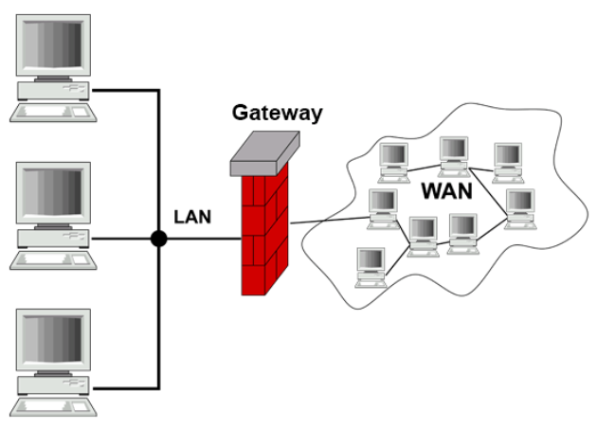

Fig. 1.10 Gateway

**f. Switches:**

A switch is a hardware device that filters and forwards network packets. A network switch also connects computers to each other, like a hub. When a switch receives a packet of data, it determines what computer or device the packet is intended for and sends it to that computer only. It does not broadcast the packet to all computers as a hub. For this reason alone, switches are usually preferred over a hub.

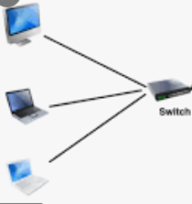

Fig. 1.11 Switch

**Sequences of Devices**

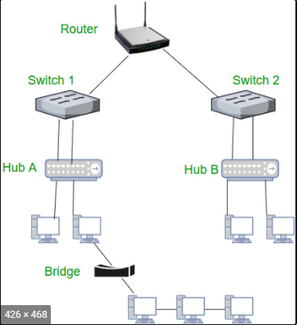

Fig. 1.12 Sequence of Devices

1.4 Software Tools

While there are many all-in-one solutions available to help you monitor, analyze, and maintain your network – we will leave the choice of which to use up to you. Here is a list of the most common tools your network management software should contain and how they can assist you in doing what you do.

* **Networking Operating System** − Network Operating Systems is typically installed in the server and facilitate workstations in a network to share files, database, applications, printers etc.
* **Protocol Suite** – A protocol is a rule or guideline followed by each computer for data communication. Protocol suite is a set of related protocols that are laid down for computer networks. The two popular protocol suites are −
  + OSI Model (Open System Interconnections)
  + TCP / IP Model
* **Bandwidth Monitor**

Monitor the average BPS and utilization percentage of interfaces, identifying traffic bottlenecks in a switch or router in real-time with this vital bandwidth tool. Presented in an easy-to-understand graphical format.

* Network Monitor

Continuously monitoring device response time, your network monitor alerts you via email, reporting node status and prioritizing severity. [Ipswich](https://www.ipswitch.com/) creates industry leading tools to visualize and monitor your network.

* Port Scanner

Track down unknown or unwanted services running on your system using a port scanner to scan for port status, associating ports with known services.

* Switch Port Mapper

Manual cable tracing is both time consuming and a total drag, save yourself from tedium and identify each switch port a device is connected to within a switch using a switch port mapper. Useful in helping you quickly assess port availability and gain real-time operational status and speeds of each port.

* System Details Update

Streamline your system details update process using this handy tool that lets you to view, scan, modify, and update the details on a range of devices all at once.

* TCP Reset

Providing a list of all established TCP connections in a device, the TCP reset lets you verify legitimate connections and reset those that are unwanted or unauthorized.

* Wake-On-LAN

Wake it up when you are on the go-go. Wake-on LAN allows you to remotely “wake” or boot up a machine in low power mode on the network with the use of a remote command. [Solar Winds](http://www.solarwinds.com/free-tools/wake-on-lan) provides free tools to manage your network power consumption and use wake-on-lan technology to save energy and remotely control system power.

**Connection of Devices**

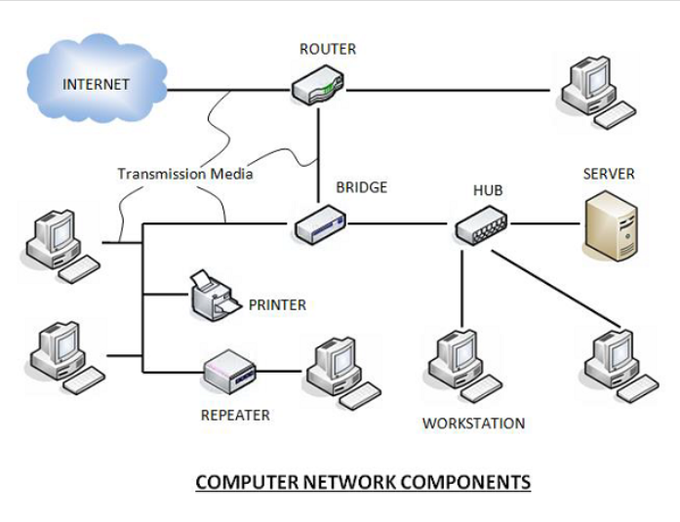

Fig. 1.13 Network Components

Chapter 2

Literature Review

**2.1 What is Networking?**

Networking refers to connected computing devices (such as laptops, desktops, servers, smartphones, and tablets) and an ever-expanding array of IoT devices (such as cameras, door locks, doorbells, refrigerators, audio/visual systems, thermostats, and various sensors) that communicate with one another.

## How does a computer network work?

Specialized devices such as switches, routers, and access points form the foundation of computer networks.

Switches connect and help to internally secure computers, printers, servers, and other devices to networks in homes or organizations. Access points are switches that connect devices to networks without the use of cables.

Routers connect networks to other networks and act as dispatchers. They analyze data to be sent across a network, choose the best routes for it, and send it on its way. Routers connect your home and business to the world and help protect information from outside security threats.

While switches and routers differ in several ways, one key difference is how they identify end devices. A Layer 2 switch uniquely identifies a device by its "burned-in" MAC address. A Layer 3 router uniquely identifies a device's network connection with a network-assigned IP address.

Today, most switches include some level of routing functionality.

MAC and IP addresses uniquely define devices and network connections, respectively, in a network. A MAC address is a number assigned to a network interface card (NIC) by a device's manufacturer. An IP address is a number assigned to a network connection.

According to Mowery, the Internet originated in a diverse set of industrial economies, the US was consistently the source of critical innovations and an early adopter of new applications. The Internet, not play a larger role in its development, particularly in the creation of new business organizations, governance institutions, and applications. The presence of a large domestic market, a set of antitrust and regulatory policies that weakened the power of incumbent telecommunications firms, and a diverse private/public research community that was willing to work with both domestic and foreign inventions were important preconditions for US leadership in computer networking innovation [1].

According to Haas, the lack of wireless spectrum in the radio frequency bands has led to a rapid growth in research in wireless networking using light, known as LiFi (light fidelity). In this paper an overview of the subsystems, challenges and techniques required to achieve this is presented [2].

According to Hayes, the concept of social networking, the focus of this article, targets the development of online communities in higher education, and, as part of the admission process. A successful case study of a university is presented on how one university has used this tool to compete for students. A discussion including suggestions on how to enhance the success of this tool in your recruitment process is also provided [3].

According to Rekimoto, this paper introduces “SyncTap”, a user interface technique for making a network connection between digital devices. When a user wants to connect two devices, he or she synchronously presses and releases the “connection” buttons on both devices. Then, multicast packets that contain press and release timing are sent to the network. By comparing this timing with locally recorded one, both devices correctly identify each other. This scheme is simple but scalable because it can detect and handle simultaneous overlapping connection requests [4].

According to Livingstone, the establishment of cooperative networks seems to be important in both processes. This paper aims to explore these aspects by analyzing the competitiveness of firms in four different sectors of the manufacturing industry: food, chemicals, electronics, and vehicles. Data have been obtained from a survey conducted specifically for this purpose at company level in Spain. Findings from the empirical analysis, based on the application of the Polytomous Logistic Universal Model (PLUM), confirm the positive effects that the ability to network has on company performance [5].

According to Farhady, Organizational and network theory are identified as the major starting points for theory building. Hypotheses are generated from the network of Euro-Atlantic security institutions, which has become the most sophisticated network of its kind since the early 1990s. The article looks specifically at the genesis of dyadic inter-organizational relations and of entire networks, at the relevance of networking for policy output and at the system effects that networks have on individual organizations. The theoretical findings are presented to allow a transfer to other geographical and functional areas of networking [6].

## How is computer networking evolving?

Modern-day networks deliver more than connectivity. Organizations are embarking on transforming themselves digitally. Their networks are critical to this transformation and to their success.

According to O'Donnell, the concepts of networks and networking as a means of exploring how entrepreneurs “do business”. More recently, attempts have been made to show how the process of networking contributes to small firm marketing. The overall research study on which this paper is based aimed to show how networking contributes to marketing. This paper focuses on a specific objective of the overall research study, namely an understanding of the process of small firm networking. It reviews previous research into the concept of networking and demonstrates how the process of networking can be captured as several dimensions along which entrepreneurial networking may vary [7].

According to Dressler, the communication and networking technologies have yielded many existing and envisioned information network architectures such as cognitive radio networks, sensor and actor networks, quantum communication networks, terrestrial next generation Internet, and Interplanetary Internet. The existing bio-inspired networking and communication protocols and algorithms devised by looking at biology as a source of inspiration, and by mimicking the laws and dynamics governing these systems are presented along with open research issues for the bio-inspired networking [8].

According to Brandtzæg, the recent popular social media platforms is the social networking site (SNS). Thus far, few previous studies have empirically investigated people’s motivations for SNS usage, especially not outside the U.S. This study combines a large-scale quantitative and qualitative research design, by asking 1,200 SNS users an open question regarding their reasons for using SNSs. An important conclusion drawn from a preliminary content analysis is that people often report many motivational reasons for using SNSs [9].

According to Bhattacharjee, Active networking offers a change in the usual network paradigm: from passive carrier of bits to a more general computation engine.  however, involves significant challenges in interoperability, security, and scalability. In this paper we define an active networking architecture in which users control the invocation of pre-defined, network-based functions through control information in packet headers. architecture allowing applications to exercise some control over network processing, the bandwidth allocated to each application’s packets can be reduced in a manner that is tailored to the application, rather than being applied generically [10].

The types of network architectures that are evolving to meet these needs are as follows:

* Software-defined (SDN): In response to new requirements in the "digital" age, network architecture is becoming more programmable, automated, and open. In software-defined networks, routing of traffic is controlled centrally through software-based mechanisms. This helps the network to react quickly to changing conditions.
* Intent-based: Building on SDN principles, intent-based networking (IBN) not only introduces agility but also sets up a network to achieve desired objectives by automating operations extensively, analyzing its performance, pinpointing problematic areas, providing all-around security, and integrating with business processes.
* Virtualized: The underlying physical network infrastructure can be partitioned logically, to create multiple "overlay" networks. Each of these logical networks can be tuned to meet specific security, quality-of-service (QoS), and other requirements.
* Controller-based: Network controllers are crucial to scaling and securing networks. Controllers automate networking functions by translating business intent to device configurations, and they monitor devices continuously to help ensure performance and security. Controllers simplify operations and help organizations respond to changing business requirements.
* Multidomain integrations: larger enterprises may construct separate networks, also called networking domains, for their offices, WANs, and data centers. These networks communicate with one another through their controllers. Such cross-network, or multidomain, integrations generally involve exchanging relevant operating parameters to help ensure that desired business outcomes that span network domains are achieved.

Only Cisco offers a complete portfolio of modern network architectures for access, WANs, data centers, and cloud.

According to Chell, networking by owner-managers of small businesses will enhance business performance. The presence of networking activity is suffused with methodological difficulties. A sparse use of institutional networks; an association between networking activity and business performance, although it seems that this must be qualified by sectoral differences; an association between type of owner-manager on a scale of entrepreneurship and networking activity [11].

According to Ida, broadband Internet access services has been remarkable. However, two main problems have emerged concerning broadband migration*:* migration from narrowband to broadband services and migration inside broadband services. Focusing on the latter problem, this paper reaches two conclusions. First, in terms of the type of users who initially migrated to the fiber to the home (FTTH) service is analyzed. It is found that income levels. Second, the lock-in effects of NTT, which provides both asymmetric digital subscriber line (ADSL) and FTTH, are analyzed [12].

According to Pavelić, the area is so broad that it touches all areas of everyday life. Since the expected number of IoT devices that will be connected in next 5 years is tens of billions, security threads are one of the crucial areas to be solved to have such huge number of connected devices. This paper is explaining different threats and on the example of smart door lock system are explained potential problems and how they are solved [13].

According to Giannakis, deals with decentralized learning algorithms for in-network processing of graph-valued data. Without exchanging elements from the distributed training sets and keeping inter-node communications at affordable levels, the local (per-node) learners consent to the desired quantity inferred globally, meaning the one obtained if the entire training data set were centrally available. Impact of the decentralized learning framework to contemporary wireless communications and networking tasks is illustrated through case studies including target tracking using wireless sensor networks, unveiling Internet traffic anomalies [14].

According to Ünver, the sphere of such a mighty system like international (mobile) communication and Internet usage and control issues are based. The multi-stakeholder community controls and manages the critical resources of the Internet. In general, we are experiencing a change or power shift due to the digital revolution on the economic basis of our global society. The change in (digital) technical infrastructure and the upcoming of powerful AI systems [15].

CHAPTER 3

FEASIBILITY STUDY

A network feasibility study is an evaluation of your broadband project to determine the estimated capital and operational costs and the impacts of these costs on the financial viability of the project. CHR's network feasibility studies services provide a customized two-phase feasibility study because every business, along with their customers, network, and location are unique. Phase I consists of the market identification and evaluation, and a detailed business case and pro-forma, associated with deployment of broadband services to identified target markets. Phase II is based on the business case results and helps determine the timeline and geographic priorities within the proposed implementation.

* Why Do I Need a Feasibility Study?

Feasibility studies are important for a communications service provider to determine whether your broadband project will succeed or not. It should be the first action taken when wanting to begin a new project. It is one, if not the most important factor in determining whether the project can and should move forward. Also, if you are applying for broadband loans and grants, a feasibility study is normally required.

* How Can CHR Help?

CHR has partnered with telephone and cable companies, electric coops, and municipalities to successfully implement a variety of communications networks. We can help you determine the right method for deploying broadband technology in Rural America. Our strategic approach gives you the tools necessary in making business decisions for building, marketing, and monetizing your network. Contact us today to discuss your broadband network projects.

* Who Have We Worked with?

CHR has experience partnering with a range of companies, organizations, and broadband service providers including:

* Telephone and Cable Companies
* Broadband Service Providers
* New VPN
* NeoOne
* LastMile
* VSAT

3.1 Technical Feasibility

Technical feasibility evaluates the technical complexity of the expert system and often involves determining whether the expert system can be implemented with state-of-the-art techniques and tools. In the case of expert systems, an important aspect of technical feasibility is determining the shell in which the system will be developed. The shell used to develop an expert system can be an important determinant to its quality and makes it vital to the system's success. Although the desirable characteristics of an expert system shell will depend on the task and domain requirements, the shell must be flexible enough to build expert reasoning into the system effectively. It must also be easily integrated with existing computer-based systems. Furthermore, a shell providing a user-friendly interface encourages end users to use the system more frequently.

3.2 Technology Description

Networking is a specific branch of information technology (IT) and is one of the fastest-growing areas of IT. It involves the processes of building, using and maintaining computer networks – including hardware, software and protocols – so that multiple computing devices can share data (sources: Technopedia; Life wire).

Networking can include home or business computer networks and wired or wireless computer networks. As well as their classification, computer networks can also differ in their design. The 2 basic forms of network design are client/server and peer-to-peer networks.

A client/server network relies on a centralized server that stores things like emails, Web pages, files, and applications, and is accessed by client computers or other client devices. In contrast, a peer-to-peer network does not rely on a centralized server – instead, client devices connect and communicate with one another to share information and support the same functions (source: Life wire).

While client/server networks are much more common among businesses, peer-to-peer networks are more common among homes. And, with networking playing a vital role for most businesses in today’s world, networking roles are in increasingly high demand.

Networking part of information technology networking is one of the many areas that IT incorporates, and is an integral sub-field of IT.

While IT covers a wide range of areas including software and web development, programming, security, systems analysis, and technical [business IT support](https://lits.com.au/services/managed-desktop/), networking is a specific area of expertise within the IT sector.

So, if you are looking to work in a role that specifically revolves around networking, then a qualification that is specific to the IT sub-field of networking is your best option.

CHAPTER 4

BACKEND DESIGN

4.1 Data Dictionary

## The heart of Africa's digital transformation.

Africa Data Centers, part of the Liquid Intelligent Technologies Group, is the region's first and largest network of interconnected, carrier and cloud-neutral data facilities.

Choosing where to store your business-critical data is one of the most important decisions your company will make. Bringing global skills to local markets, we are your trusted partner for rapid and secure data services and interconnections across the African continent.

Africa Data Centers are designed, built and operated to the highest standards demanded by today’s leading cloud providers, carriers and enterprises – providing your business with peace of mind, regardless of the scale of requirement.

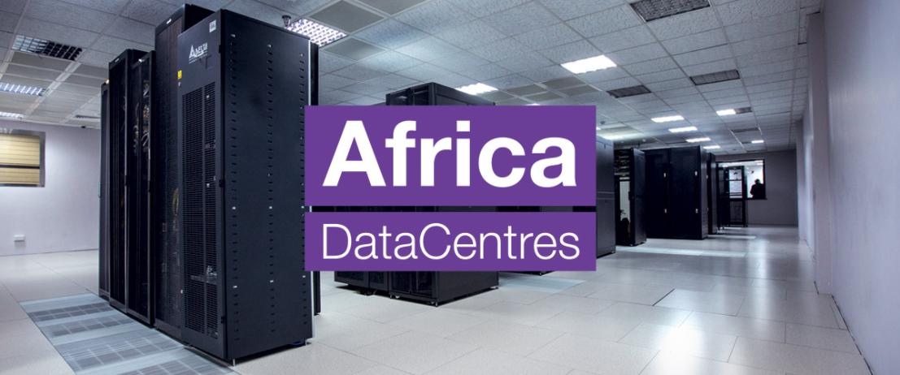

Fig. 4.1 Data Center

* A single network like no other

Since putting our first fiber in the ground in 2009, our high-speed cross-border network has grown to over 100,000km of fiber. It is the continent’s largest independently owned network, offering connectivity to all the main subsea cable systems that link Africa to the rest of the world.

We are also the first to establish a direct terrestrial communication link between Cape Town, South Africa, and Cairo, Egypt - stretching the entire length of the continent and offering improved latency.

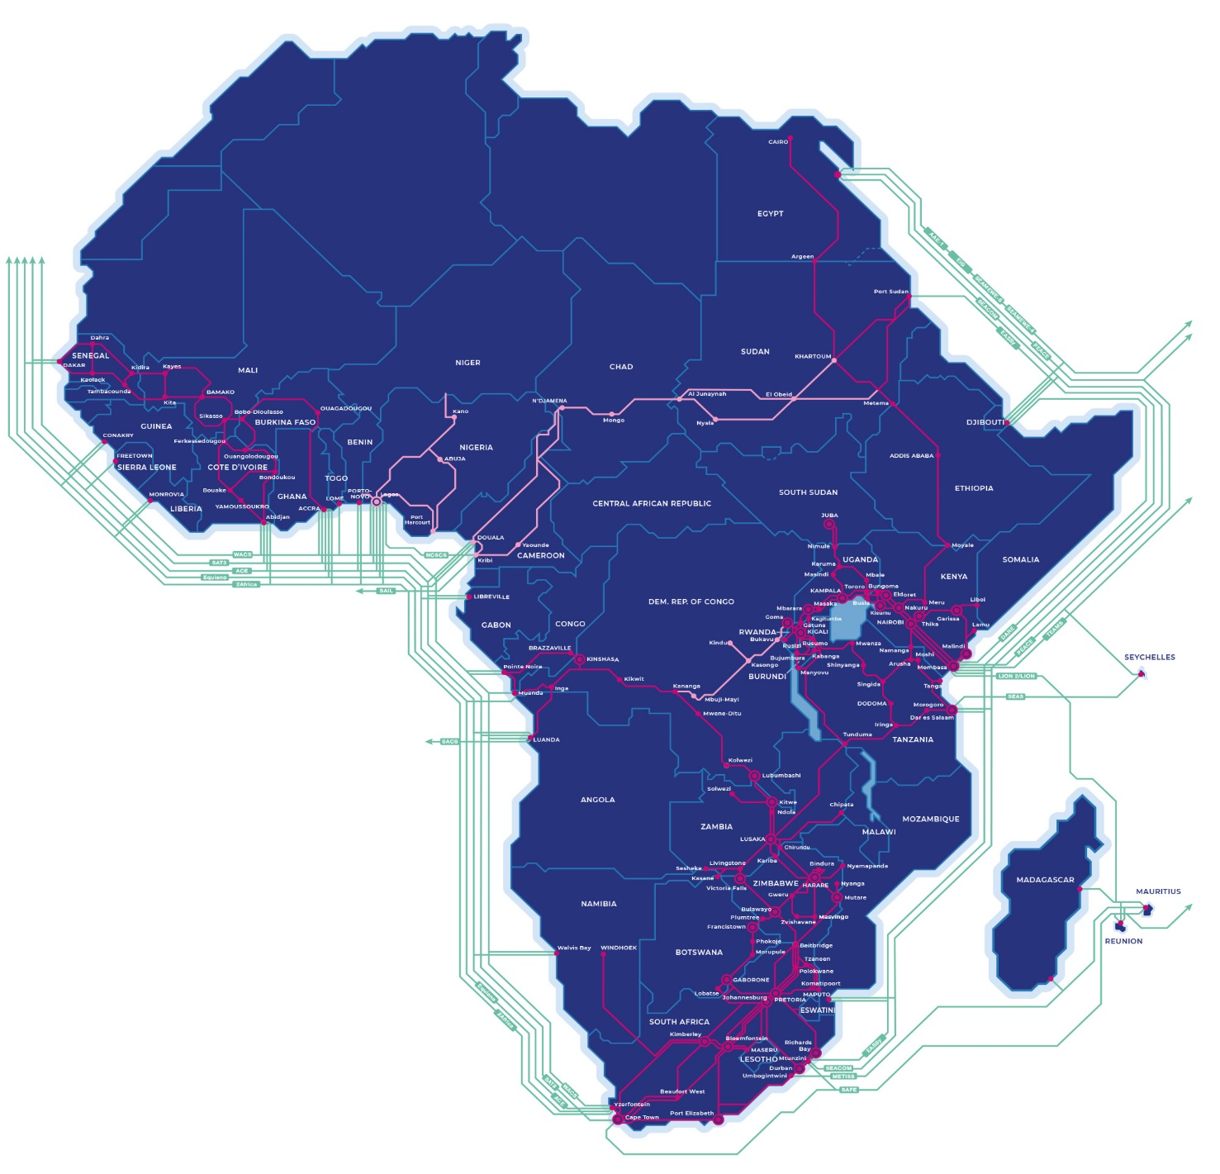

Fig. 4.2 connectivity location

### Our award-winning network immediately

* Africa’s largest independent fibre network, spanning over 100,000km.
* A reliable and highly protected, self-healing switched backbone that prioritises traffic within Africa to reduce latency.
* State-of-the-art data centres in Johannesburg, Cape Town, and Nairobi, with a combined potential 19,000 square metres of rack space and 78 MW of power
* Consortium member in SAT3/SAFE, WACS, TEAMS and Easy, as well as a large IRU inventory holder in SEACOM and a shareholder in WIOCC
* Onwards connectivity to major international hubs such as London and Marseille

## Empowering Africa through excellence

Choosing where to store your business-critical data is one of the most important decisions your company will make. By bringing global skills to local markets, we are your trusted partner for rapid and secure data center services and interconnections across the African continent.

Africa Data Centers are designed, built and operated to the highest standards demanded by today’s leading cloud providers, carriers and enterprises – providing your business with peace-of-mind, regardless of the scale of requirement.

Our facilities are purpose-built and entirely owned and operated by us. This means the physical and digital security of your data and transactional computer processing remain front-of-mind from the physical layer up.

## The Africa Data Centre’s Advantage

### Pan-African Footprint

Africa Data Centers are located across Africa’s major regional business and trade hubs. These locations are rapidly emerging as epicenters for public and private cloud hosting, attracting both multinationals and the largest African enterprises.

### Robust Security

The physical security of your data and transactional computer processing remains front-of-mind from the physical layer up. Onsite security is guaranteed by multiple layers. It is a combination of physical security, biometric access control and CCTV systems. Africa Data Centers are ISO 27001 certified and PCI DSS compliant.

### International Expertise

Africa Data Centers brings global skills and expertise to your local market. With an exceptionally experienced team you can rest assured that years of experience and knowledge has equipped our team to provide excellent support.

### Carrier & Cloud Neutral

Africa Data Centers is the primary choice for international cloud and content providers. This ensures that our facilities are equipped no matter what network or cloud onramp your business requires.

### Operational Excellence

Africa Data Centers are designed, built and operated to the highest standards demanded by today’s leading cloud providers, carriers and enterprises – providing your business with peace-of-mind, regardless of the scale of requirement.

### Interconnected

Africa Data Centers is Africa’s largest network of interconnected carrier- and cloud-neutral data facilities. Over 50 leading carriers call Africa Data Centers their home, as do major internet exchanges, including the Johannesburg Internet Exchange (JINX), Cape Town Internet Exchange (CINX) and Kenya Internet Exchange Point (KIXP).

4.2 ER DIAGRAM

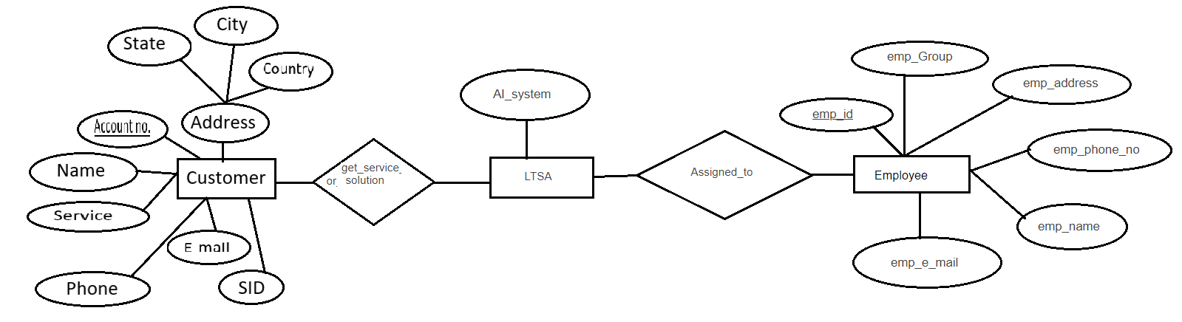

Fig. 4.3 ER Diagram

4.3 DFD

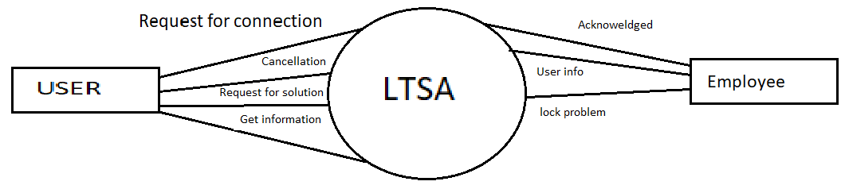

Fig. 4.4 DFD

4.4 Database table

1. This is for store the information of CPE information to get the addresses of devices.

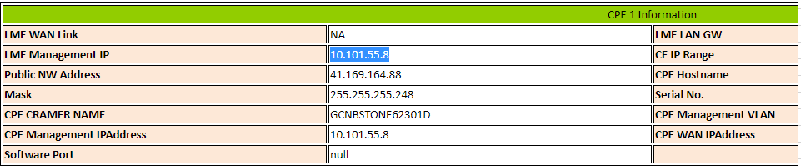

Table. 4.1 CPE

**2.** This table to store the complete information of user.

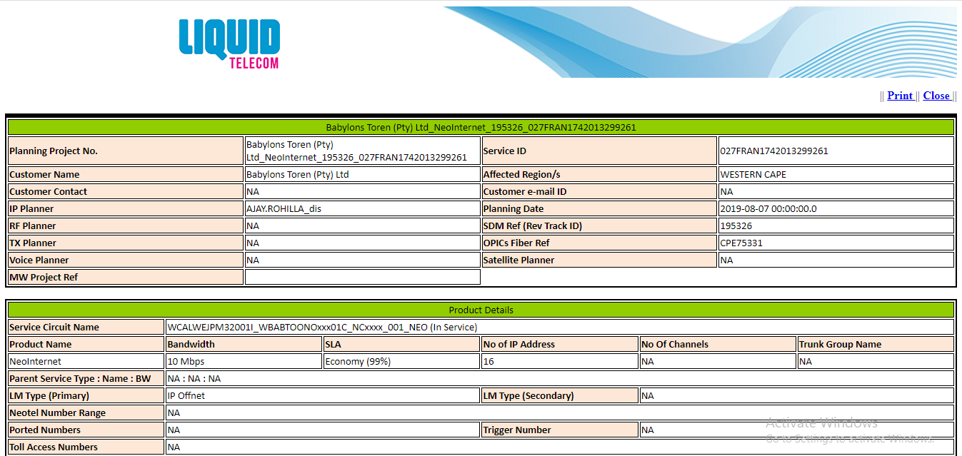

Table. 4.2 User information

4.5 Architecture

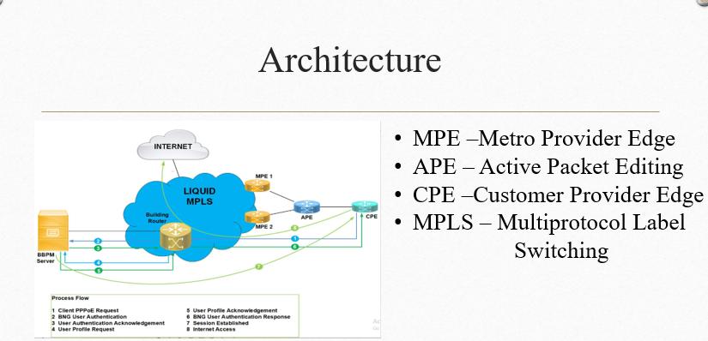

Fig. 4.5 Architecture

CHAPTER 5

Frontend Design

5.1 Input screenshot

**1>** This screenshot for new case when the customer facing any type of problem then customer fill this form.

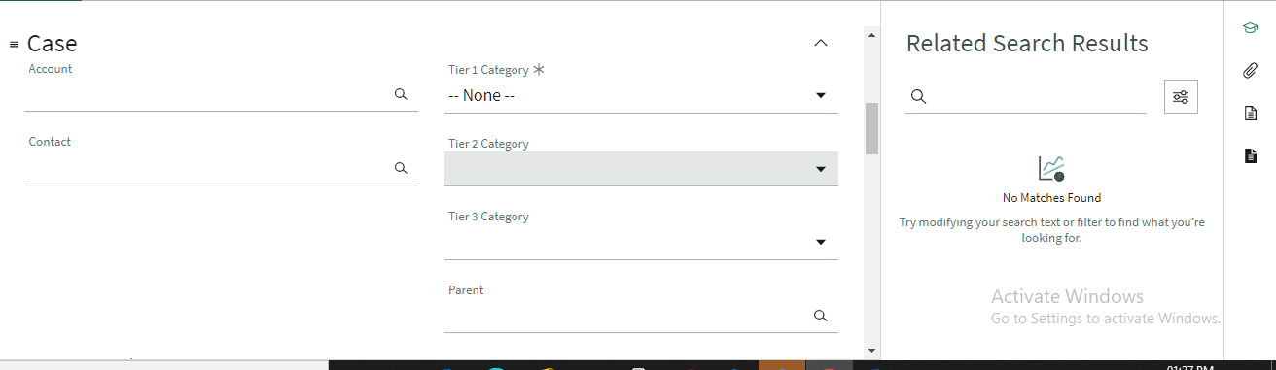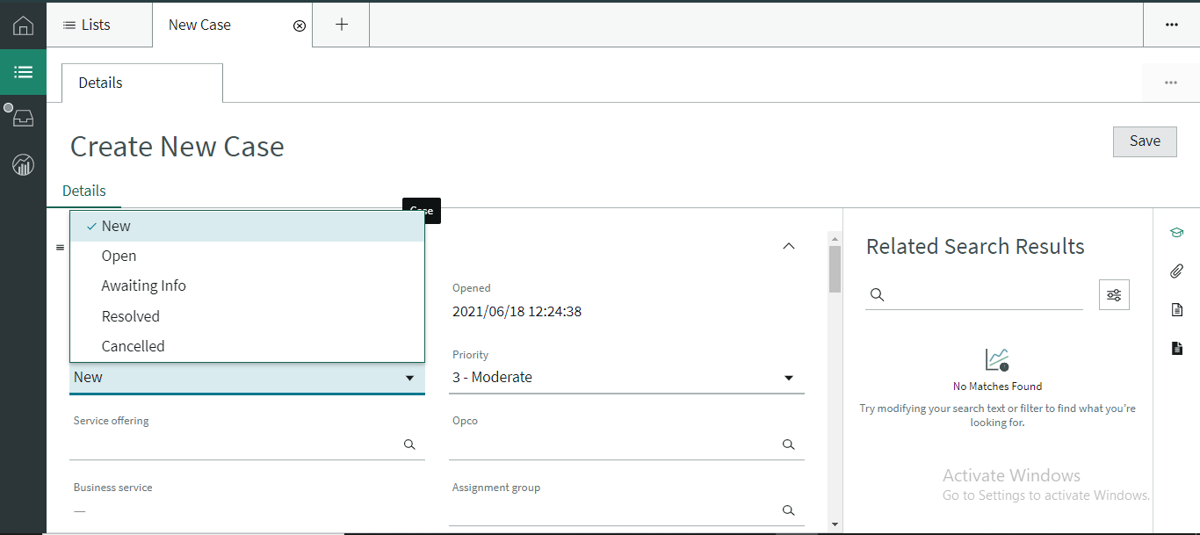



**2>** This screenshot for employee when customer fill detail and send to company then employee do the work of their request based on service id.

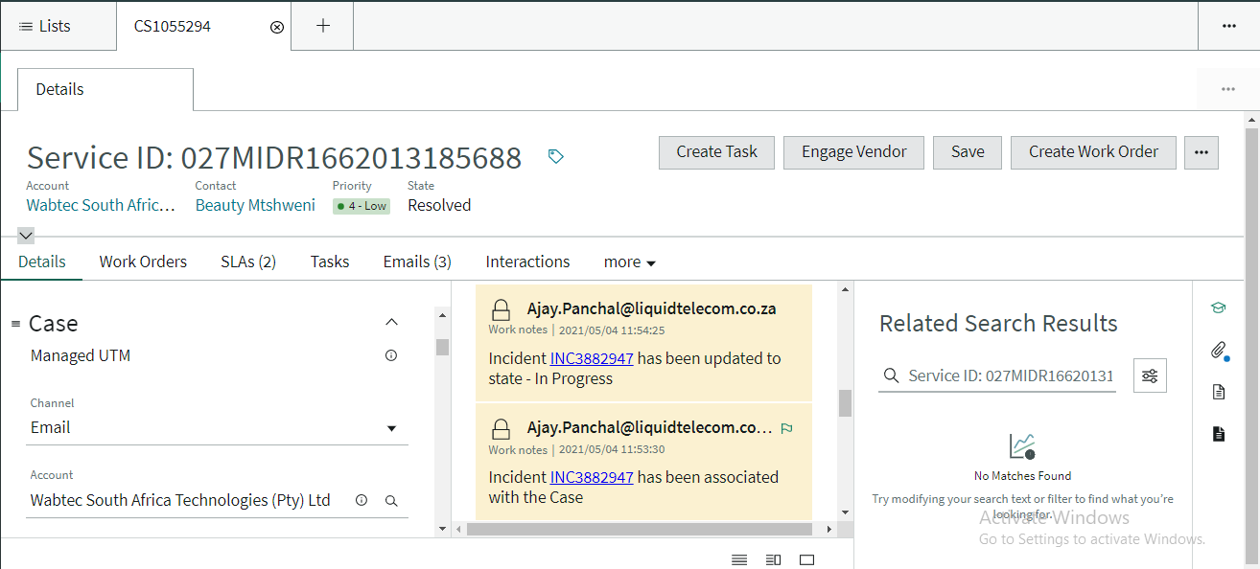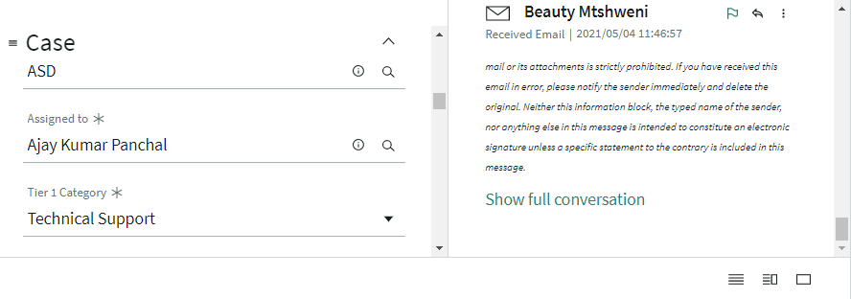

Fig. 5.2 Incident



Fig. 5.3 Onboarding process

5.2 OUTPUT

This screenshot is output for all information related to problem of customer and employee to get the status of problem.

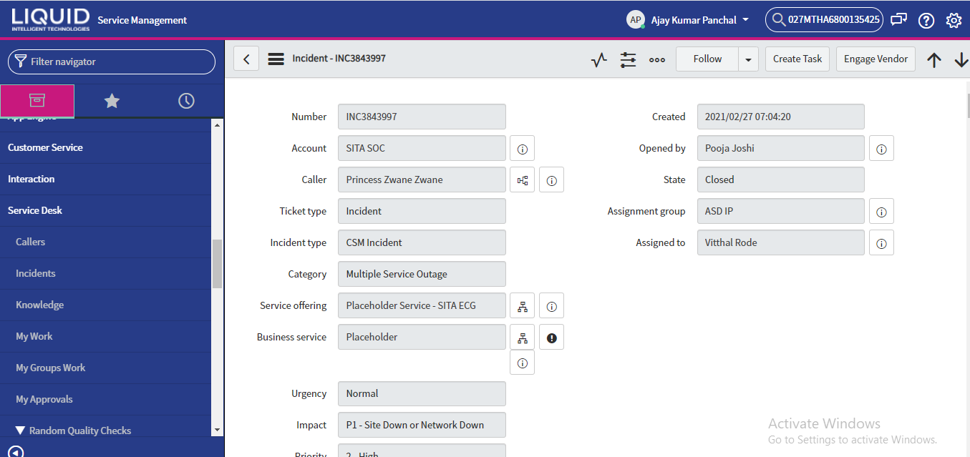

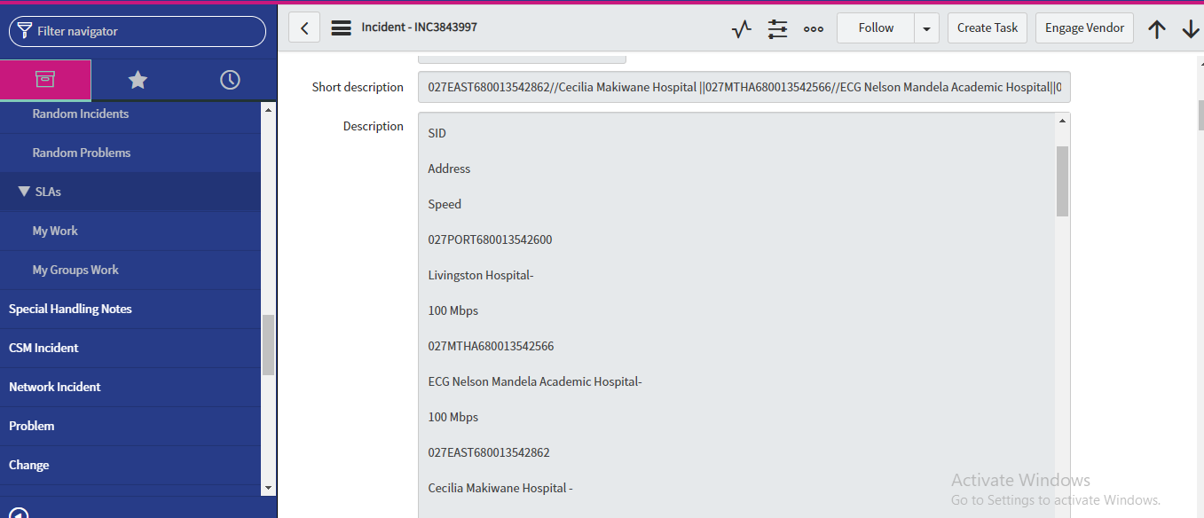

Fig. 5.4 output

CHAPTER 6

Report

6.1 Report

This screenshot for get all the information of customer.

 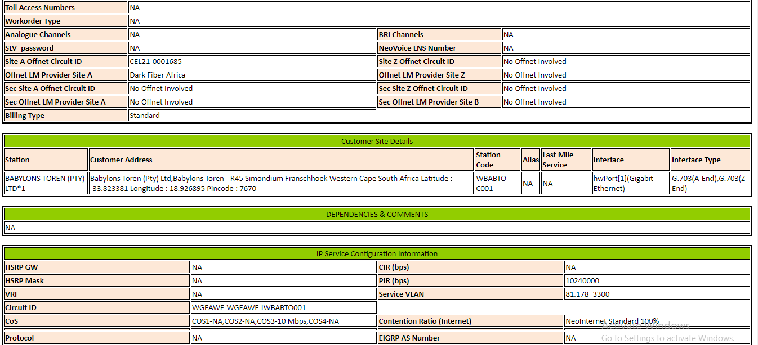 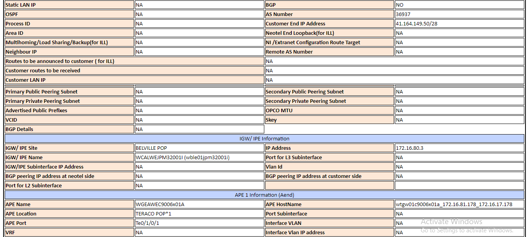 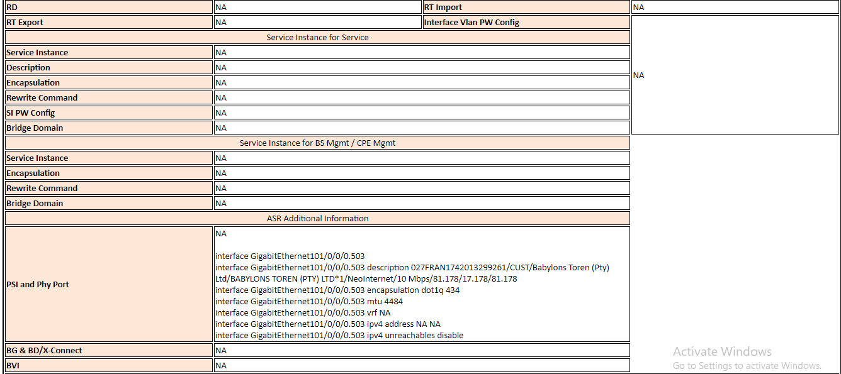 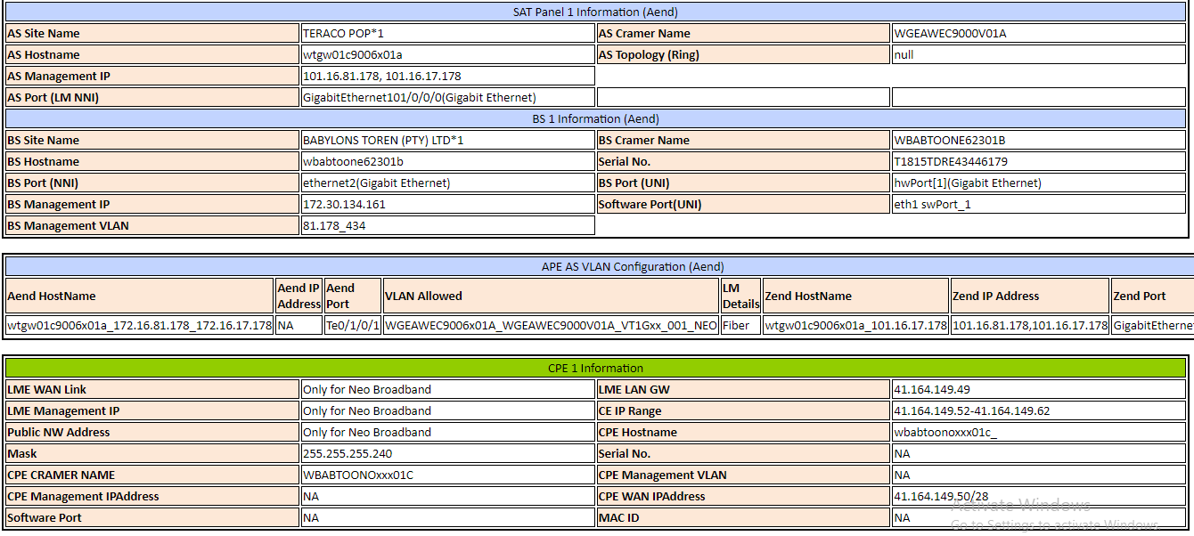 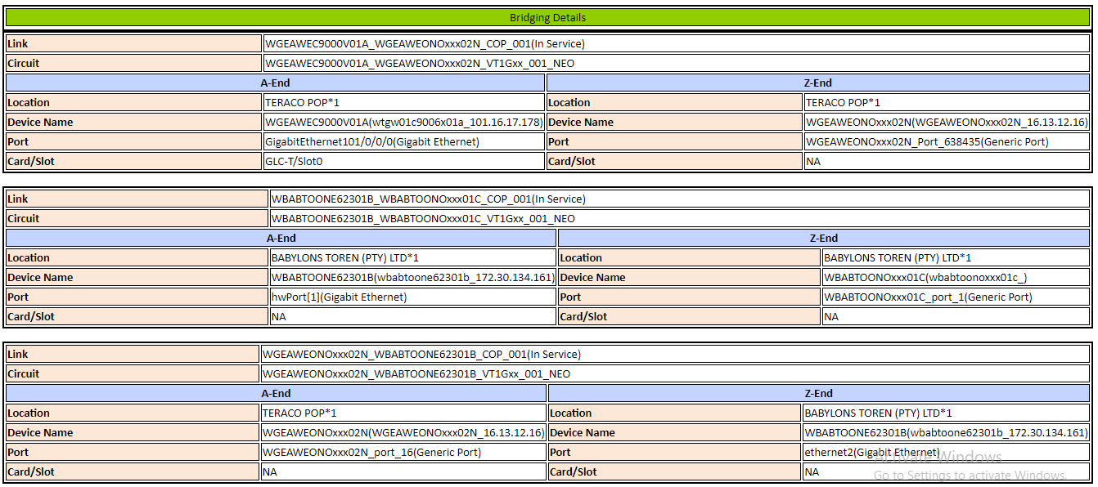

Fig. 6.1 customer information

CHAPTER 7

TESTING

7.1 Testing Screenshot

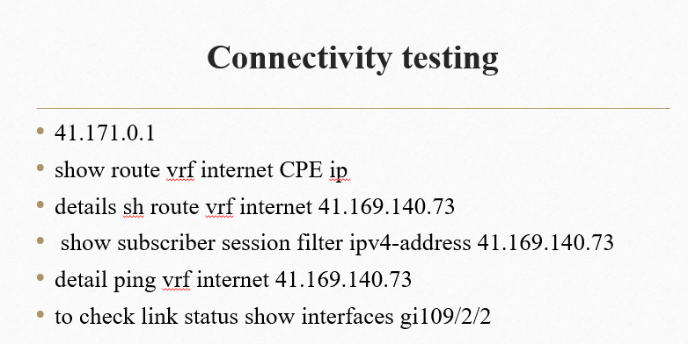

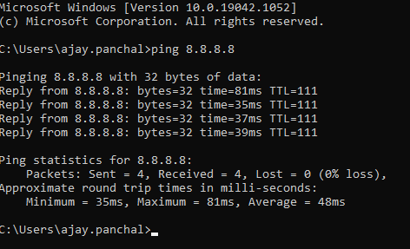

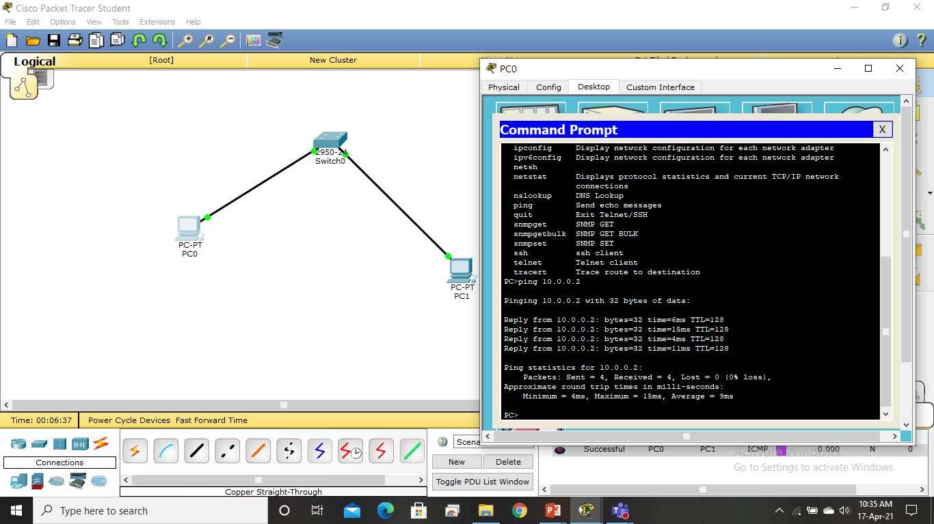

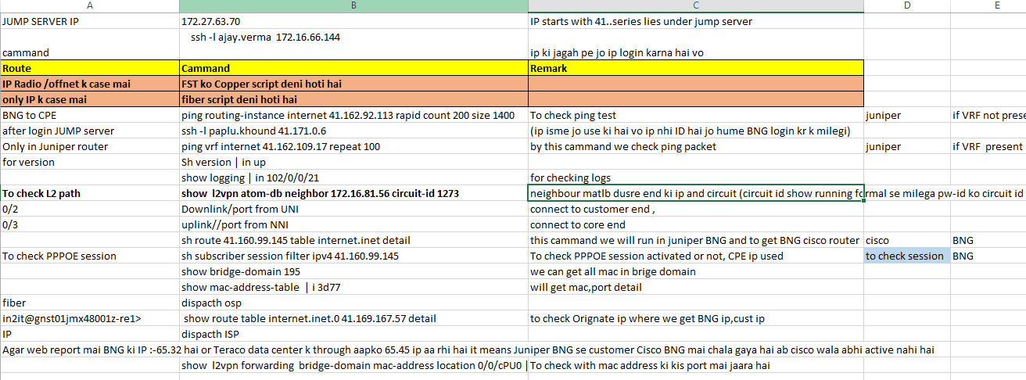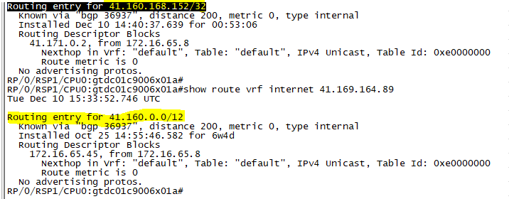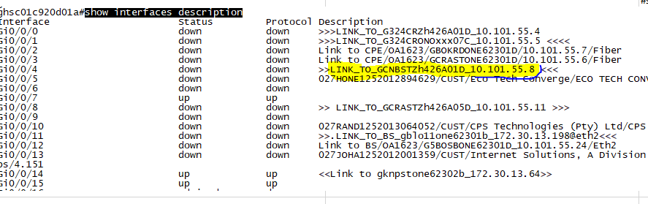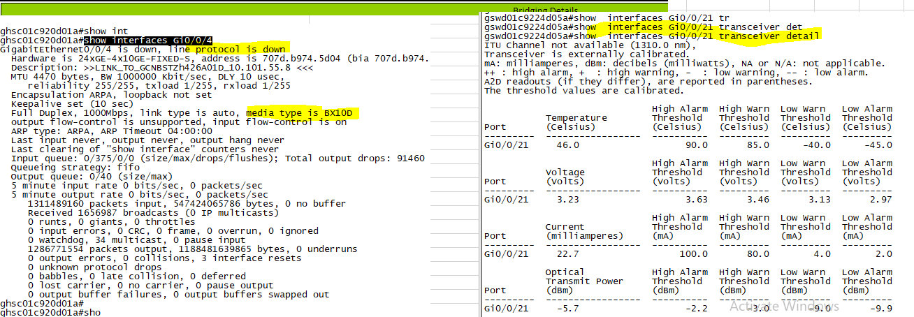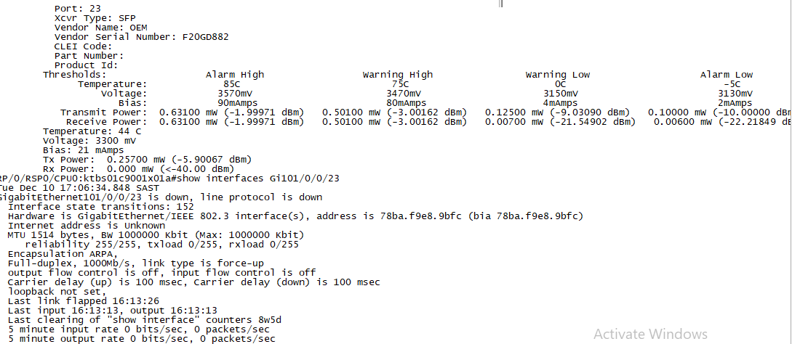

Fig. 7.1 testing on cmd

CHAPTER 8

Limitation

* Security Issues

Data and information are more prone to illegal access than where there is no networking. Computer crimes like tapping of information is common

* High Initial Costs

Initial costs of acquiring network resources like hardware and software is high

* Moral and Cultural Effects

Large networks like the internet have chat rooms and messaging services that enable underage children to meet peers and adults on the net some of whom may have bad intentions. e.g. access to drugs information and pornographic contents

* Spread of Terrorism and Drug Trafficking

The easy flow of information keeps even those who are on the wrong side of the law communicating easily. Terrorists and drug traffickers use information networks for their business communications

* Over - Reliance on networks

All businesses these days is dependent on computer networks. And if a network fails, businesses will halt to a standstill and bring enormous losses.

* Bandwidth Issues

In a network there are users who consume a lot more bandwidth than others. Because of this some other people may experience difficulties.

8.1 Future scope

* There is a vast future scope of this Network. This Design can be improved and can be used by various banks. If the limitations present in this Design are removed then, this Network will become very reliable and provide 100% uptime.
* We can easily implement any changes to the Network Design as we are using the latest protocol like Border Gateway Protocol (BGP) in our network which is having attributes to easily divert or control the flow of data and QOS which can be used to allocate bandwidth to servers accordingly.
* The scope of a network refers to its geographical size. A network can range in size from just a few computers in one office to thousands of computers linked together over great distances.
* Network scope is determined by the size of the organization or the distance between users on the network. The scope determines how the network is designed and what physical components are used in its construction.

8.2 Future Enhancement

## Networking

In technology, 'networking' is connecting a system of computers to share information. The Internet is just that type of service, and new ideas and better systems are being developed every day. We can define the Internet as a 'cloud' or repository for files and services that we can access, but that are not on our computers directly.

Technology is advancing every day. Ten years ago, nobody would have imagined that you could start your car from your phone, or your refrigerator could order food from Amazon! While we can't tell you, what is going to happen tomorrow, let alone 5 years from now, we can use existing technology and trends to predict possibilities of the future.

* Fi 6 and Wi-Fi 7

**Wi-Fi 6** is faster Internet, up to 9.6 Gbps (consider that Wi-Fi 5 is 3.5 Gbps!). However, Wi-Fi 6 not only addresses speed, but it helps manage multiple devices connected to a network. This is critical because so many of us are working from home, streaming movies/TV, and posting updates to social media on our hand-held devices. Plus, our furnaces, refrigerators, microwaves, and stoves are also connected to the Internet. As such, there is a need for something to handle all that increased demand.

Where today's routers can easily become overwhelmed with so many connected devices, Wi-Fi 6 routers can handle the load and distribute the speed. You may not get a huge boost on all the devices, but you won't see such rapid degradation in speed and response. That is the benefit of technology. There will only be more and more devices connected to networks: a better management tool is needed, and the future is Wi-Fi 6, and even **Wi-Fi 7** is looming on the horizon!

Wi-Fi 7 is 802.11be, the latest standard. While this functionality is still a bit further out, it has some increased capabilities over Wi-Fi 6. It can send data on several frequencies simultaneously, use two bands (or even three) at once, and it further increases the information it can send over the network.

* 5G

**5G** is a rage today, with wireless carriers touting their prowess in this realm. There's 5G and ultra-wide 5G in larger cities. This promises more coverage at much faster speeds. At the time of writing this lesson, Verizon was pushing 723 Mbps. That's pretty decent if you're streaming your favorite team's soccer match.

But the future of 5G is probably a bit more 'personal'.

5G enables the Internet of Things (**IoT**), such as thermostats, refrigerators, drones, security systems, etc. The backbone for many of these IoT services is an enhanced fiber network. You may even have a fiber network installed in your neighborhood or home. This underlying power will give 5G applications a big boost.

* Automation

Are the bots going to take over? Probably not yet, but automated processing is booming in numerous industries. Networking is no exception. From day-to-day management of networks to deployment of large networks, automation will play an ever-increasing role.

Automation is more than artificial intelligence or machine learning; thousands of routine and mundane tasks can now be taken over by automatic processes. But speaking of machine learning and artificial intelligence...

* SD-WAN

**SD-WAN**, or **Software-Defined Wide-Area-Networks**, are networks that rely heavily on software to control services and connectivity. Once thought of as cool new technology, SD-WANs usage will increase as companies use it to connect their branch offices to the cloud.

With a software-driven network and cloud computing, there would be one central networking point. No longer would there be a need for full data centers in other parts of the world, the problem could be solved via the cloud.

CHAPTER 9

CONCLUSION

In conclusion, in short, this project is how to configure the network by complete understanding the tool. Main learning of this project was how to make the different subnets, how to assign a default gateway address, how to use VLSM, how does routers learn about various routes. We were able to successfully install GNS3, VPCS topologies were successfully built implementing various protocols.

A network is two or more computers connected using a telecommunication system for the purpose of communicating and sharing resources. Without having a network, Companies would not be able to share resources and increase productivity more effectively. The WAN network allowed companies to use the Internet over large areas. This provided the company to have meetings overseas by video conferencing and sharing data over the network. As you can see, Networks have many benefits to the end user. Weather your Network is Wired or Wireless, Networks are an important part of technology.

Networking Initiative showed that in the absence of resources allocated to promote collaborative activities among people busy with their own current endeavours, it is very difficult to maintain interpersonal interactions. A great deal of organizing must be done by those most involved in establishing a new network, especially one that links people across several traditional fields.

The Native Computer Communications Network Project was a good example of how a focus on creating a network of computers does not necessarily ensure the interpersonal networking of the potential users of that technology. If the people were not communicating with each other before, developing another method of communication does not mean they'll start.

Habnet was a project that tried to overcome the limitations of these initiatives. It succeeded as an exploration of the potentials of online interactions but failed to thrive when it ceased to grow. It again showed how difficult it is to create an online network without enough people to maintain enough interaction, and thereby enough interest, to make it worthwhile to use.

Computer communication, it seems, will become a much more useful networking tool when large numbers of people with similar interests acquire access to the technology. Though it can expedite the formation of new interpersonal networks by overcoming the space and time barriers faced by traditional networking techniques, it still requires a great deal of concentrated effort and resources to get the people to use it. This problem should become increasingly minimized over the coming years as the technological innovations become more diffused throughout society.

CHAPTER 10

BIBLIOGRAPHY

* + 1. <https://www.investopedia.com/terms/n/networking.asp>
    2. <https://www.ibm.com/in-en/cloud/learn/networking-a-complete-guide>
    3. <https://www.cisco.com/c/en_in/solutions/small-business/resource-center/networking/networking-basics.html>
    4. <https://en.wikipedia.org/wiki/Computer_network>
    5. <https://hbr.org/2016/05/learn-to-love-networking>
    6. <https://searchnetworking.techtarget.com/definition/networking>
    7. <https://in.topresume.com/career-advice/importance-of-networking-for-career-success>
    8. <https://www.youtube.com/watch?v=gvC04PSdAog>
    9. <https://www.businessballs.com/building-relationships/networking/>
    10. <https://www.youtube.com/watch?v=n2D1o-aM-2s>

CHAPTER 11

References

1. Mowery, D. C., & Simcoe, T. (2002). Is the Internet a US invention? —an economic and technological history of computer networking. *Research Policy*, *31*(8-9), 1369-1387.
2. Haas, H., Chen, C., & O'Brien, D. (2017). A guide to wireless networking by light. *Progress in Quantum Electronics*, *55*, 88-111.
3. Hayes, T. J., Ruschman, D., & Walker, M. M. (2009). Social networking as an admission tool: A case study in success. *Journal of Marketing for Higher Education*, *19*(2), 109-124.
4. Rekimoto, J., Ayatsuka, Y., & Kohno, M. (2003, September). SyncTap: An interaction technique for mobile networking. In *International Conference on Mobile Human-Computer Interaction* (pp. 104-115). Springer, Berlin, Heidelberg .
5. Livingstone, S., & Brake, D. R. (2010). On the rapid rise of social networking sites: New findings and policy implications. *Children & society*, *24*(1), 75-83.
6. Farhady, H., Lee, H., & Nakao, A. (2015). Software-defined networking: A survey. *Computer Networks*, *81*, 79-95.
7. O'Donnell, A. (2004). The nature of networking in small firms. *Qualitative market research: an international journal*.
8. Dressler, F., & Akan, O. B. (2010). A survey on bio-inspired networking. *Computer networks*, *54*(6), 881-900.
9. Brandtzæg, P. B., & Heim, J. (2009, July). Why people use social networking sites. In *International conference on online communities and social computing* (pp. 143-152). Springer, Berlin, Heidelberg.
10. Bhattacharjee, S., Calvert, K. L., & Zegura, E. W. (1997, April). An architecture for active networking. In *International Conference on High Performance Networking* (pp. 265-279). Springer, Boston, MA.
11. Chell, E., & Baines, S. (2000). Networking, entrepreneurship and microbusiness behaviour. *Entrepreneurship & regional development*, *12*(3), 195-215.
12. Ida, T., & Sakahira, K. (2008). Broadband migration and lock-in effects: Mixed logit model analysis of Japan's high-speed Internet access services. *Telecommunications Policy*, *32*(9-10), 615-625.
13. Pavelić, M., Lončarić, Z., Vuković, M., & Kušek, M. (2018, October). Internet of things cyber security: Smart door lock system. In *2018 international conference on smart systems and technologies (SST)* (pp. 227-232). IEEE.
14. Giannakis, G. B., Ling, Q., Mateos, G., Schizas, I. D., & Zhu, H. (2016). Decentralized learning for wireless communications and networking. In *Splitting Methods in Communication, Imaging, Science, and Engineering* (pp. 461-497). Springer, Cham.
15. Ünver, H. (2018). Global Networking, Power and Control Issues. In *Global Networking, Communication and Culture: Conflict or Convergence?* (pp. 197-220). Springer, Cham.